A promotion starts with a bottom under the category of “Coupon”
- Go to Company View and create a “Coupon”
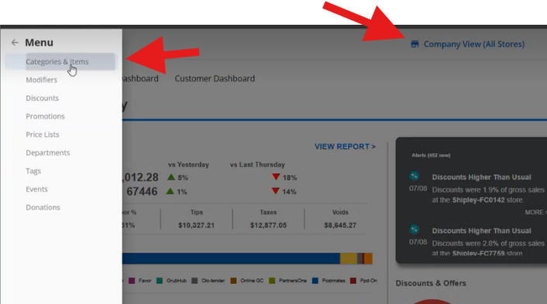
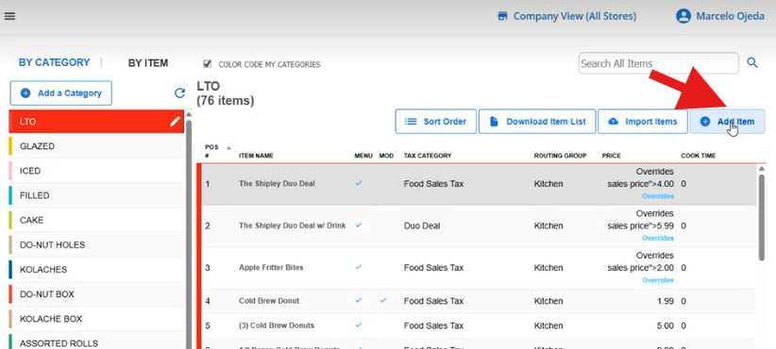

- Create the Bottom under the category “Coupon” and fill out the Item Name in this case “Summer Promo x”
- Ensure that “Routing Group” is blank

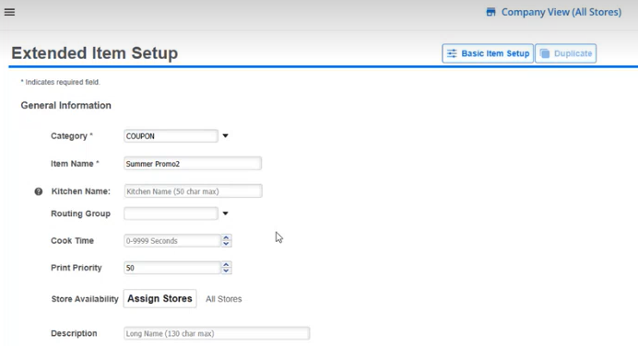
- Go to Stores and unselect “all stores” and select only “Lab1 and Lab 2” and press “Done”
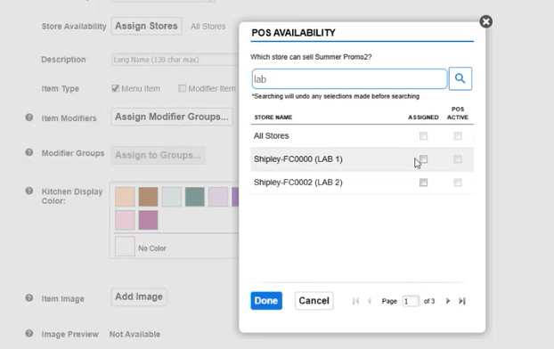
- Once back on the creation page, ensure that is selected “Menu Item”
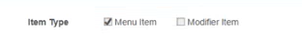
- Remain all the additional fields as it is. And click on “Save”
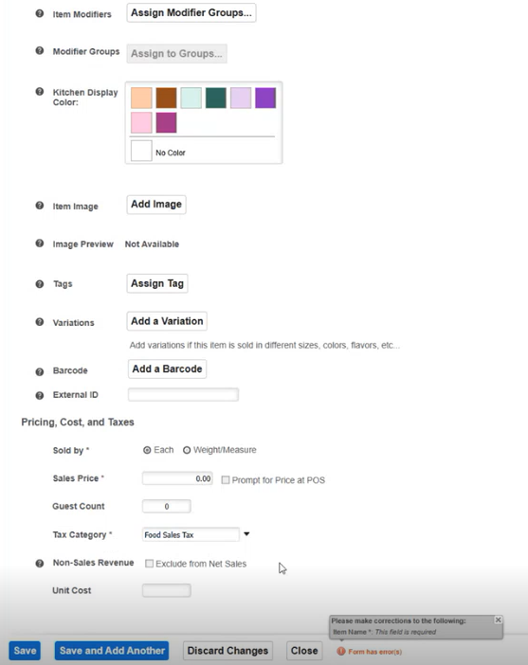

- Now, let’s create the promotion. Go to the Left Menu and select “Promotions” and then go to the top right and select “Add a Promotion”
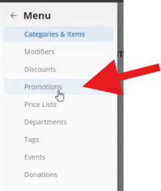
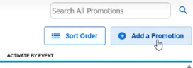

- Fill out the “Name” with the same name on the Bottom that was created on step 2. This is very important for tracking purposes. And then, click on “Assign Stores” and assign to Lab 1 and Lab 2”
Select on “Trigger” Apply manually
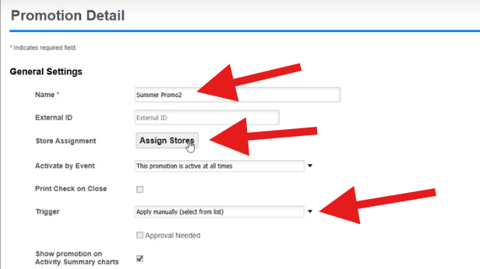
Note: If it was requested, the promotions can schedule for a period or hours.
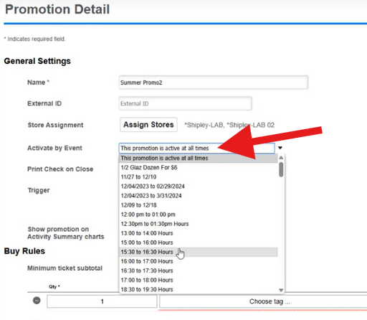
- Now, Let´s create the tag for the promotion. Main Menu > Tags.
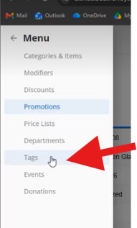
- To create a new Tag, if is for Promotion on the name should be like this: z*(promo name, should be the same as point 8). If is only an item, can be created with a regular name.
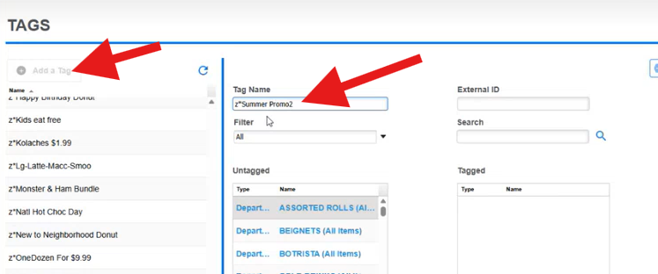
- Once the tag is created, is necessary to add the promotion to the tag, as follow: 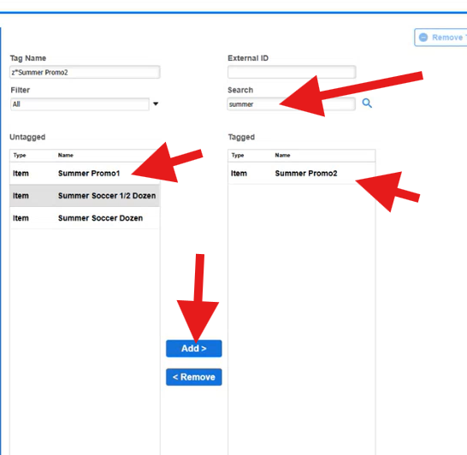
Search the promotion name that was created on point 8 > It will show on Untagged section > select and click on “Add” > It will show on tagged now.
- Lets go back to the create a Promotion Section, the tag have to be added to the Promotion: 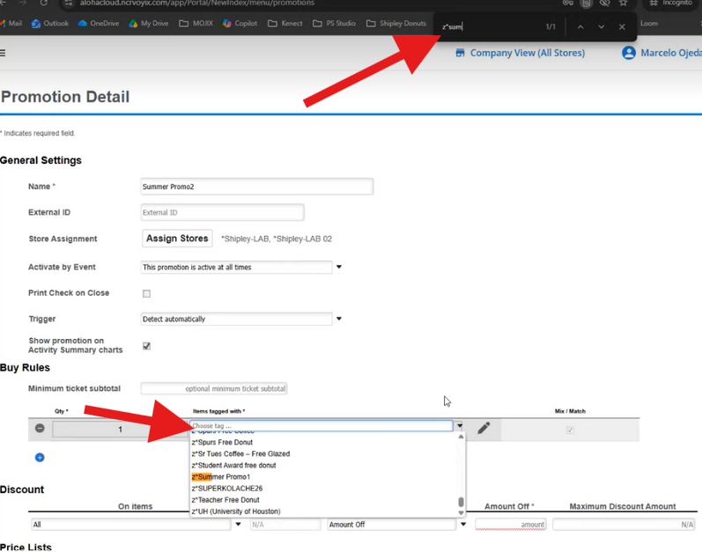
In “Buy Rules”, open the drop down menu where it will show the Tag that was just created. > Crtl F > and search for the “z*xxxx” name.
- Now, verify that the products that want to be assigned to the promotion, are existing on the store. Open NCR on a Hidden window and go the store “price list” to review each item.
- Review if each item that the store wants on the promo have a Tag.
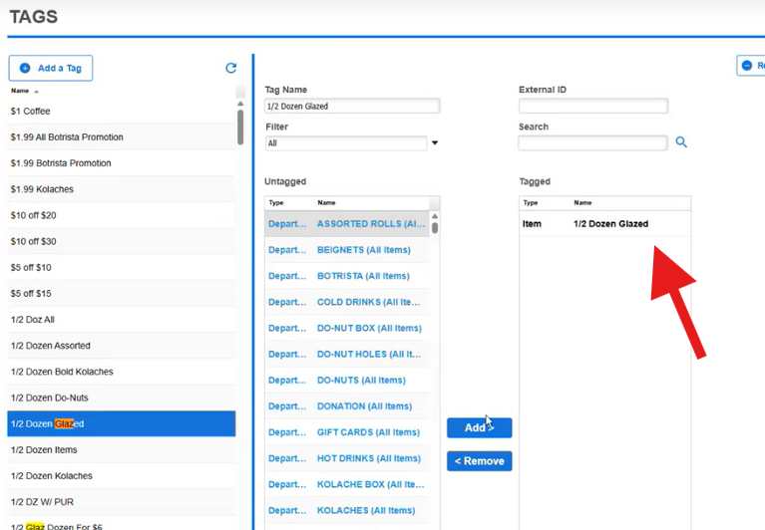
Main Menu > Tag
Search for the item to add to the promotion (most of the items are already showing on the tags).
If the Tag contains any of the items that the store is asking. Is OK.
- Let’s go to Promotion section > Add the tag as the products that the store wants to add to the promo.
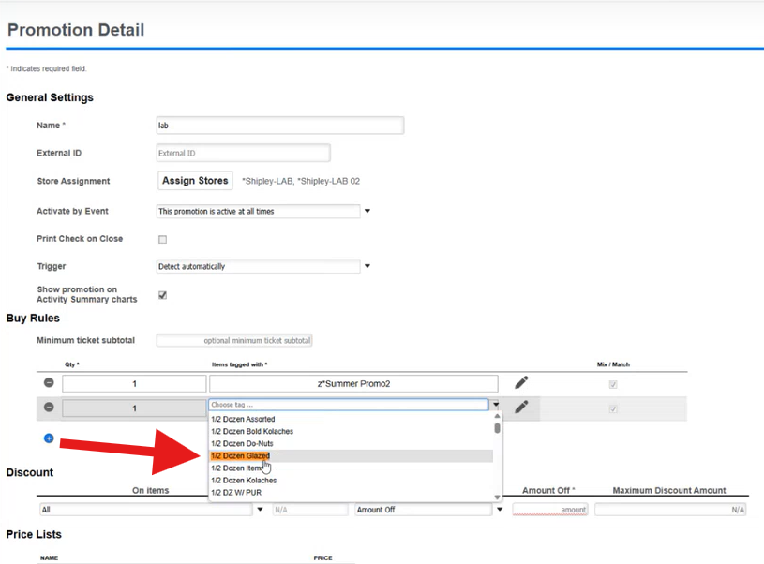
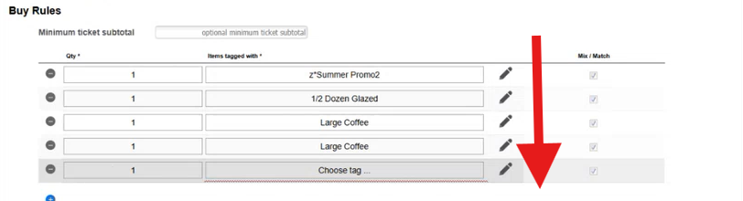
- Now, fill out the following section as follows, cinluding the price that was requested for the promotion. Click Save.
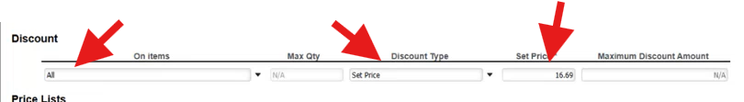

Create promotions in OLO

- ON the main Dashboard look for Guests - > Coupons
- Click on “Create a New Coupon”

- Select the best promotion that the store is asking and continue with the next steps.
- Consider to add only the Labs as a first instance for testing.
- Once we got the confirmation, the promotion can be added to the store.

